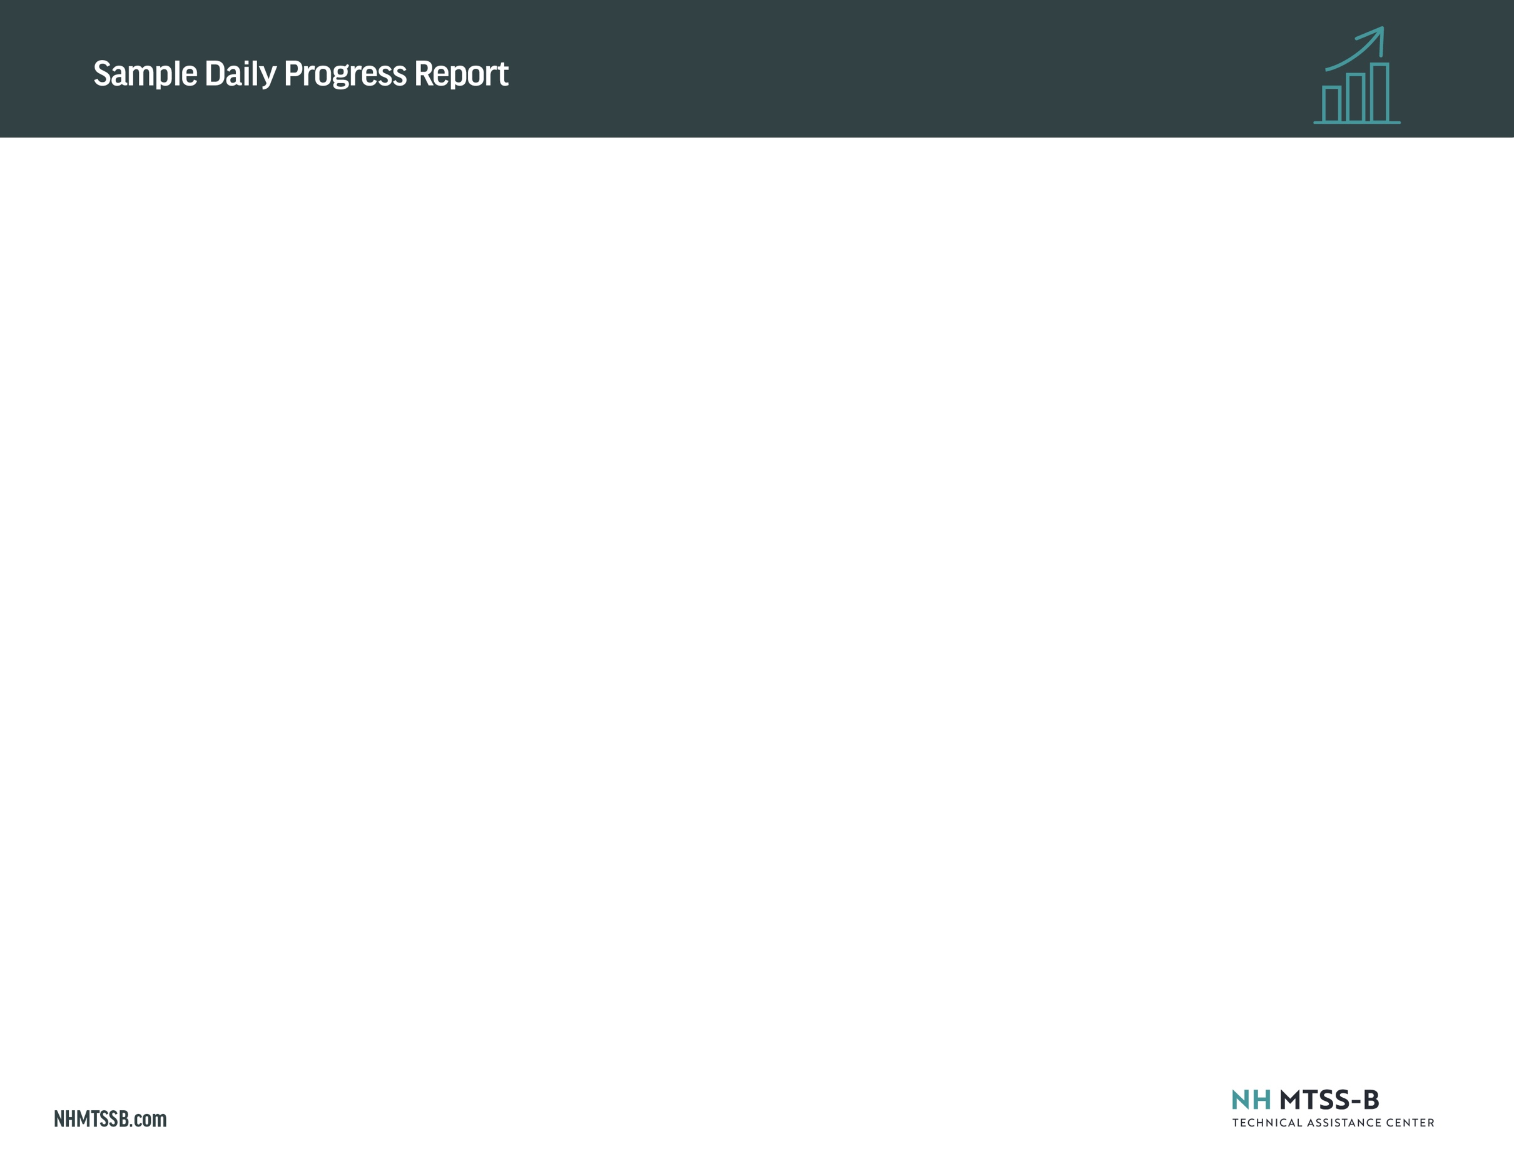
Instructions: This example provides an illustration of how schoolwide behavior expectations and student-specific strategies can be integrated into a daily progress report used in Check In/Check Out and other similar Tier 2 interventions. Modify the Behavior Expectations and descriptors to match your schoolwide behavior expectations. Add/remove Student Strategies as appropriate for the student’s individualized social-emotional needs and goals.

Name: ___________________________________
0 = Not at all demonstrating the expectation/strategy
1 = Somewhat demonstrating the expectation/strategy
2 = Entirely demonstrating the expectation/strategy

Date: ____________________________________

 |  | 1st block | 2nd block | 3rd block | 4th block | 5th block | 6th block | 7th block
 | Behavior Expectation 1  Sample: Be Safe: Keep hands, feet and objects to self | 0 1 2 | 0 1 2 | 0 1 2 | 0 1 2 | 0 1 2 | 0 1 2 | 0 1 2
Behavior Expectation 2  Brief descriptor |  | 0 1 2 | 0 1 2 | 0 1 2 | 0 1 2 | 0 1 2 | 0 1 2 | 0 1 2
Behavior Expectation 3  Brief descriptor |  | 0 1 2 | 0 1 2 | 0 1 2 | 0 1 2 | 0 1 2 | 0 1 2 | 0 1 2
Student Strategy 1  Sample: Use calming strategy if anxious |  | 0 1 2 | 0 1 2 | 0 1 2 | 0 1 2 | 0 1 2 | 0 1 2 | 0 1 2
Student Strategy 2  Brief descriptor |  | 0 1 2 | 0 1 2 | 0 1 2 | 0 1 2 | 0 1 2 | 0 1 2 | 0 1 2
Total Points
Teacher Initials
Comments:
Parent/Guardian Initials_______________

