
Use this form to request behavioral health or wellness support for a student from the Tier 2/3 Team (use your local advanced tier team name here). Please provide the main reasons for the request, as well as which data sources/evidence support the request.

Date of request: Click or tap to enter a date.
Name of person making request:
Relationship to student: Teacher Administrator Staff Family member Peer Self
Student Name:
Grade:
Student’s teacher (edit as needed for middle/high school):
Does this student have an IEP (check one)? Yes No
2 of 2
What are the main reasons for the request? (Check all that apply)
Acting out (classroom disruption, defiance, disrespect, fighting, etc.)
Sad/withdrawn
Attention problem
Attendance or academic concerns
Social/friendship concerns
Family concerns
Substance misuse
Grief/loss (major life event, death, divorce)
Concerns about school belonging (isolation, bullying/harassment, etc.)
Self-harm or harm to others
Other: please describe using the questions below
What specifically have you seen/heard/observed that has led to the concern?
Answer here
What types of supports/interventions have already been tried for this student, if any?
Answer here
What would be different if services are successful? What result are you hoping for?
Answer here

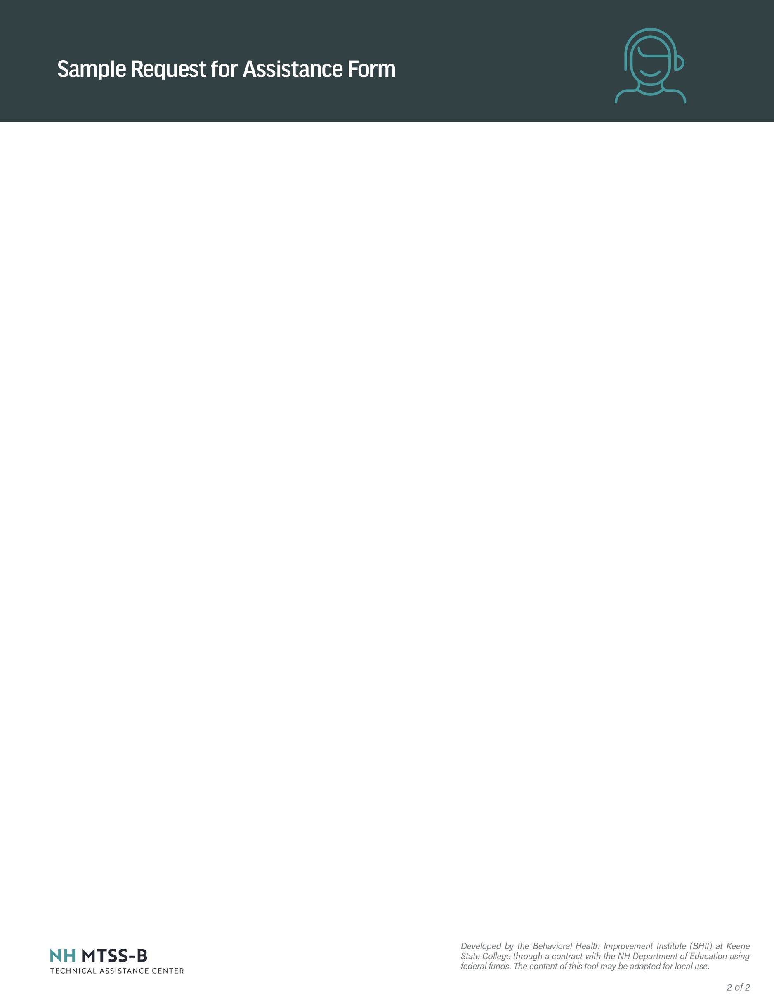
How did this concern come to your attention? Did any of the following data sources/evidence support this request? Check all that apply. Please do not submit any documentation with this request:

Teacher/staff observation
Parent/guardian observation
Peer observation
Office discipline referrals
Attendance records
Academic performance
Nurse visits
Universal screening scores
Suicide/risk assessment scores
Other (please describe):
Please briefly provide any additional comments/context for this request below:
Answer here

Please submit this form to (describe your local school procedure for sending requests to the appropriate team member(s)

